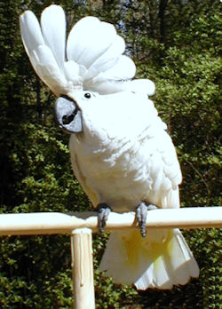

Although the Umbrella Cockatoo is not known for its capacity to talk, it more than makes up for it with its affectionate and friendly personality. This is a parrot that will normally be friendly with anyone. It loves to cuddle, and seem to thrive on any attention that it can get. It is wonderful with children as well as adults. Although all of the Cockatoos have the reputation of being people birds, the Umbrella is probably the most all-around friendly of them all.
Because it is very emotional, the umbrella must not be given any more attention as a youngster than it will receive as it gets older. It must be taught at an early age that there are times that it must entertain itself. If these lessons are not taught when young, it may become very demanding and begin screaming, or, even biting, to get attention.
Undesirable behaviours can be avoided by teaching babies simple commands, such as "Up" and "Down", and by consistently enforcing rules with patience and persistence. Try not to develop a routine of taking him out at the same time every day. Deviation from a routine will not be understood, and he may rebel in the only way he knows, screaming his disapproval to get your attention. Most of the problems that may be encountered with an older cockatoo are the result of a spoiled, undisciplined baby.

